**Manually Deploy Spring Boot application into IBM Cloud**

**1) Create Cluster in IBM Cloud**

ibmcloud plugin install container-service -r "IBM Cloud" (optional)

ibmcloud plugin install container-registry -r "IBM Cloud" (optional)

ibmcloud cs cluster-create --name <cluster name>

ex: ibmcloud cs cluster-create --name mycluster-test1

ibmcloud cs clusters

**2) Create Container Registry with Namespace**

ibmcloud cr namespace-add <my namespace>

ex: ibmcloud cr namespace-add namespace-test2

**3) Create API key (optional)**

ibmcloud iam api-key-create <my api key name>

ex: ibmcloud iam api-key-create api-key-test2

**4) Login to IBM Cloud**

ibmcloud login -a https://cloud.ibm.com -u passcode -p <?>

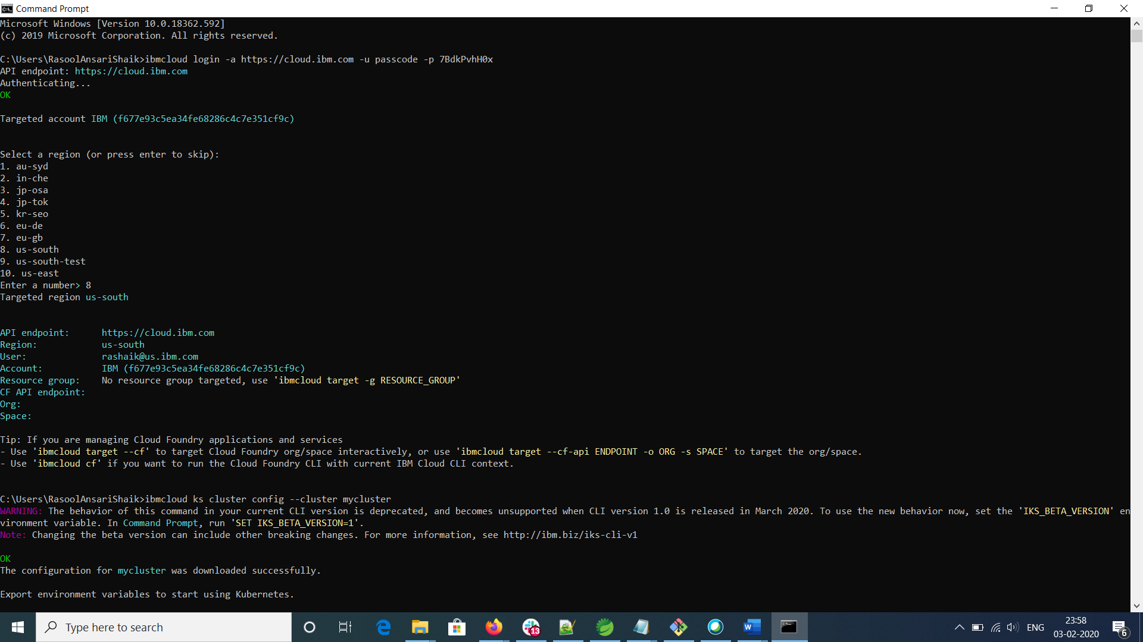

**5) Configure Kubernetes service with the cluster and set KUBECONFIG environment variable**

ibmcloud ks cluster config --cluster mycluster

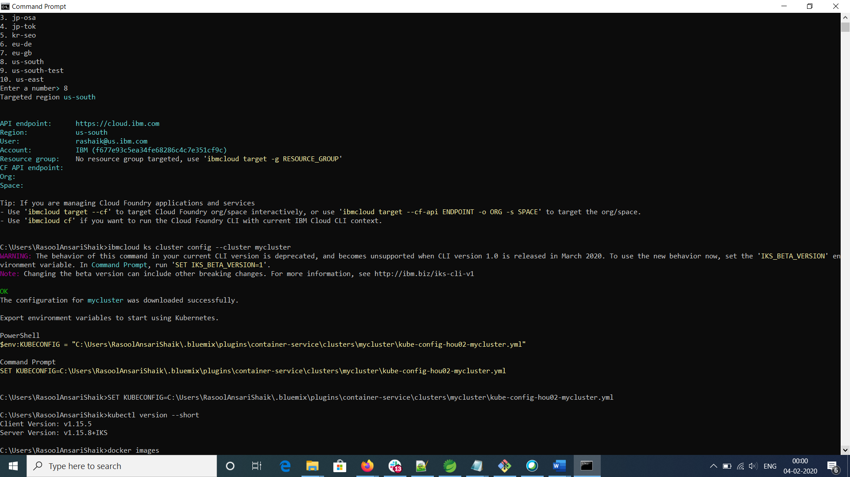

**6) Create Docker image on the working directory**

docker build -t hello-world:v1 .

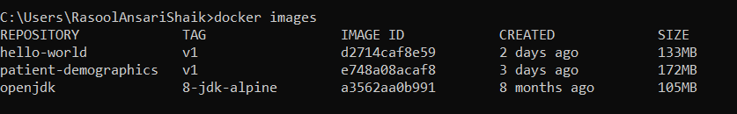

**7) Tag Docker image**

docker tag hello-world:v1 us.icr.io/namespace-test1/hello-world:v1

Reference: <https://cloud.ibm.com/kubernetes/registry/main/start>



**8) Container Registry login using ibmcloud**

ibmcloud cr login

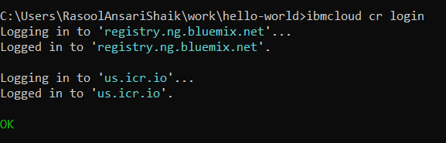

**9) Push Docker image to Container Registry**

docker push us.icr.io/namespace-test1/hello-world:v1

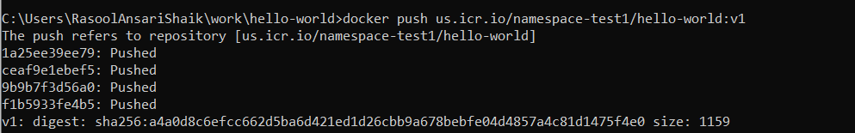

**10) You can see the image in Container Registry**

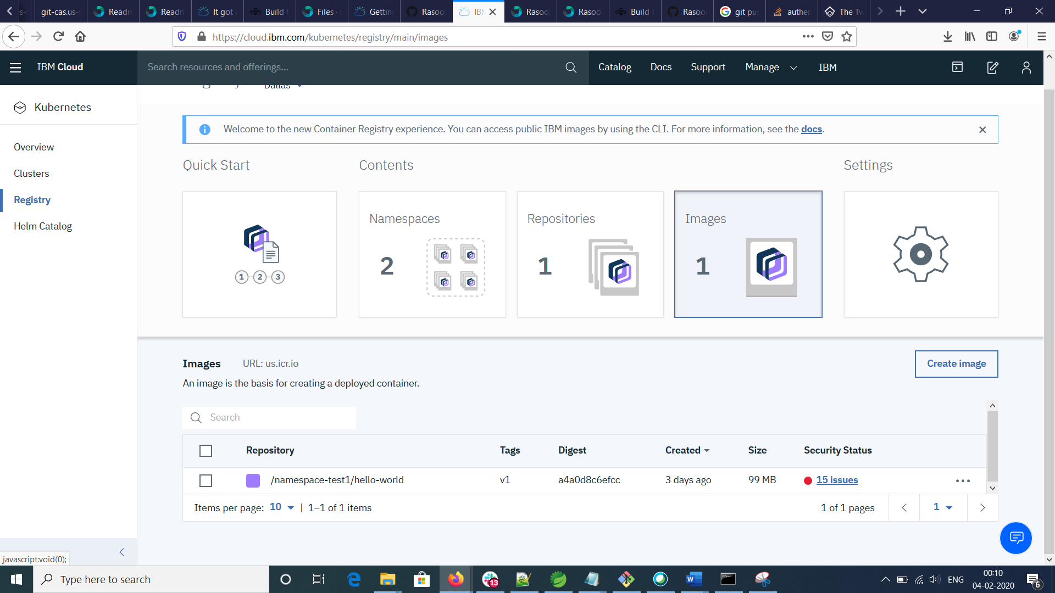

Note: There are some security vulnerabilities shown up.

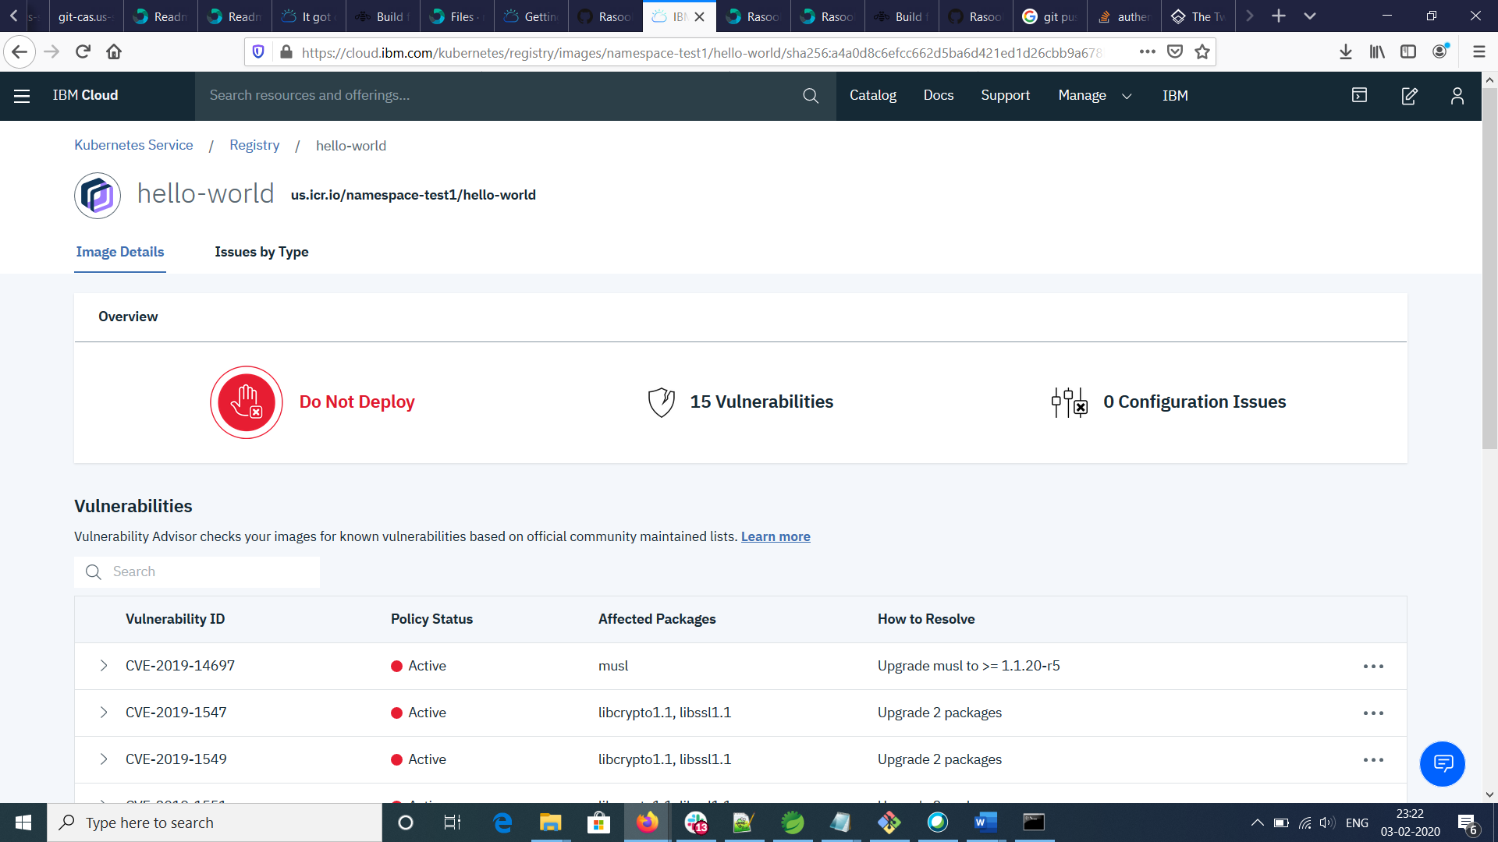

**11) Prepare the deployment & service yaml file for the deployment of this application**

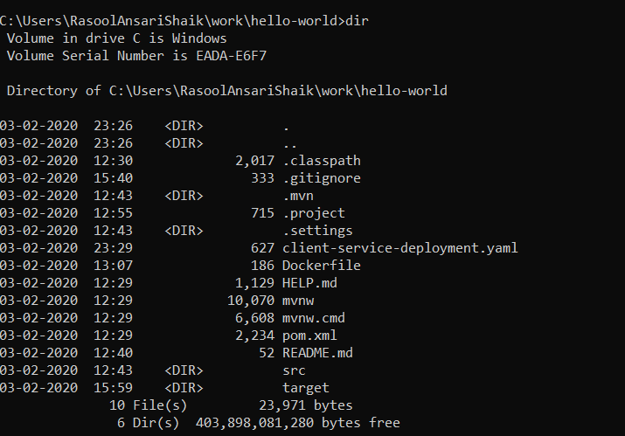

**12) Deploy the application using kubectl**

kubectl apply -f client-service-deployment.yaml

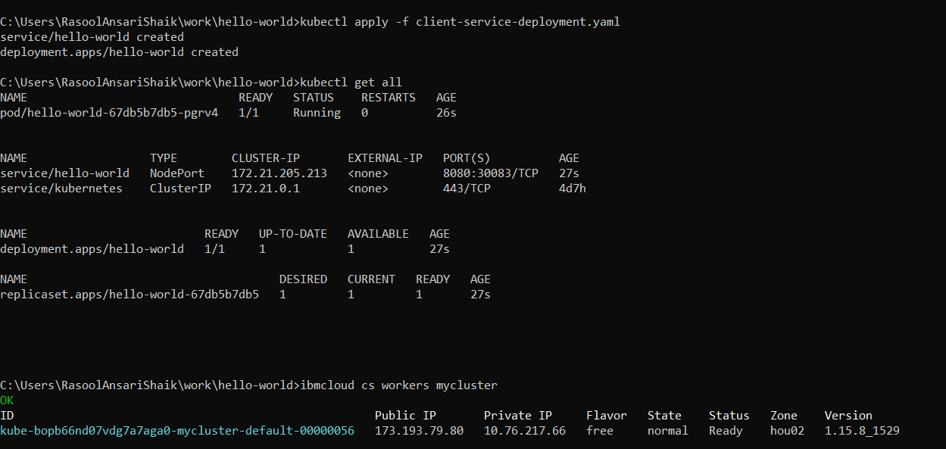

**13) Use Public IP and node port to access the application endpoints**

curl <http://173.193.79.80:30083/hello>

